

X

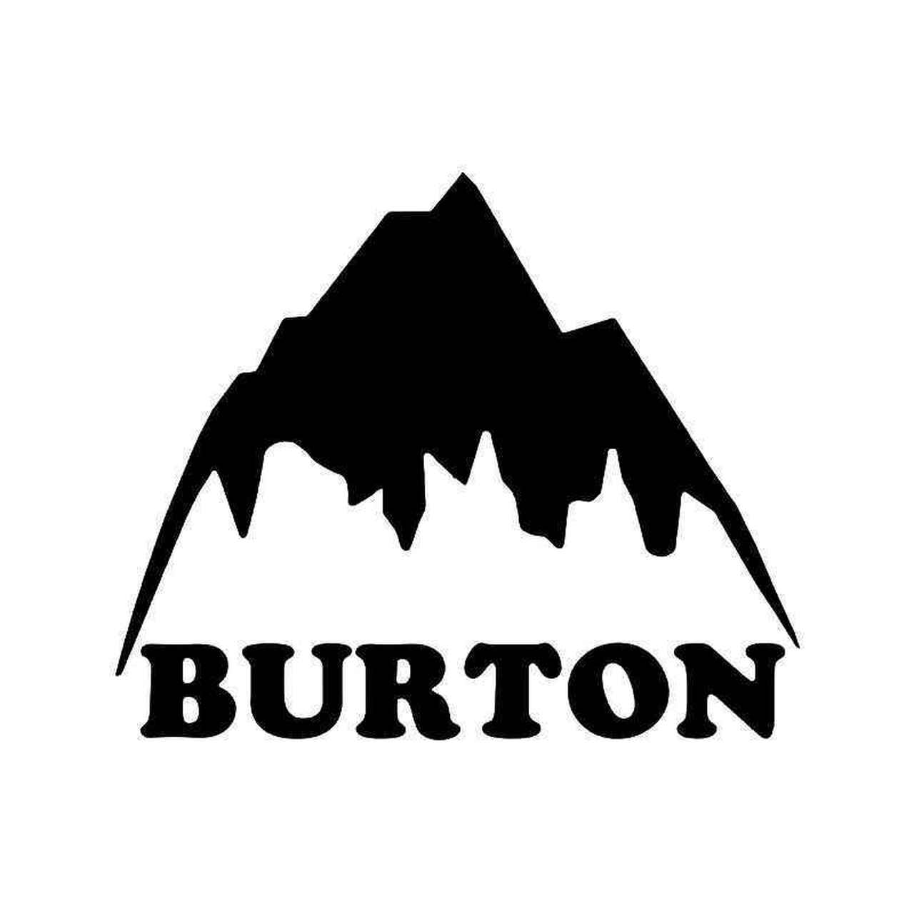

**CONTENTS**

Client Overview/Description………………………………………1

Audience Description………………………………………………2

System Requirements……………………………………………..3

Images ……………………………………………………...…………4

Typefaces ………………………………………………………….....5

Print Project (Flyer) ………………………………………………..6

Flyer Storyboard…………………………………………………….6

Website Project………………………………………………………7

Website Flowchart…………………………………………………...8

Website Storyboards………………………………….…………….9-11

Planning……………………………………………………………….12

Production Schedule……………………………………………….13

Job Descriptions…………………………………………………….14

Job Announcements…………………………………………….…15-16

**CLIENT OVERVIEW/DESCRIPTION**

Kith was founded and established in 2011 by Ronnie Fieg. As a prominent figure in the footwear industry with twenty years of experience, he applied his knowledge and experience toward the creation of Kith. Since its inception, Kith has become a prominent force not only as a multifunctional lifestyle brand for men, women, and children but also as a progressive retail establishment. The company has expanded its physical reach through the opening of seven flagship stores located in major cities throughout the world. Kith pushes the boundaries of traditional retail and fashion to provide consumers with a unique experience. The brand offers a curated selection of multiple designer brands and its own in-house label on its website and in its storefronts. Through different collaborations and original designs, Kith has remained progressive and relevant with their releases. The company delivers new products on a weekly schedule through their *Monday Program* which produces limited quantity drops that are collaborative and/or have a centralized theme. Kith has become the favorite brand of many due to their unique designs, quality products, and relevant collaborations. With the winter season approaching, Kith would benefit from a collaboration with a popular winter brand, such as Burton, to produce original content that utilizes the simple, bold designs of Kith to depict the sport and lifestyle of snowboarding. From the perspective of a consumer, such as myself, this collaboration would be an effective and creative way to expose the snowboarding community to Kith and appeal to an even broader audience. Furthermore, this collaboration would exemplify the creativity and flexibility that the client has historically proven to demonstrate. While many other brands produce and participate in collaborations, Kith has repeatedly proven itself to be successful in this endeavor with a variety of other brands. Additionally, the client has been able to maintain relative affordability without sacrificing quality; however, its competitors have been unable to do so. For this reason, it is crucial that this collaboration remain true to the brand and release products that are high-quality and relatively affordable.

To promote this collaboration, the communications plan will include:

1. A website that presents the collaboration between Kith & Burton
2. A flyer previewing the lookbook that promotes and organizes the different products included within the release

**AUDIENCE DESCRIPTION**

Kith targets men, women, and kids of all ages. While there are only seven physical store locations, the current website is available internationally. This allows for a highly diverse population for Kith to bring in as consumers. Due to the nature of the company, such as its contemporary styles, relevant collaborations, and cost, Kith appeals heavily to consumers that are fashion focused and follow current trends. For this campaign, the target audience includes Kith’s existing consumer base as well as middle to upper class consumers who are enthusiastic about snowboarding and/or fashion. Kith’s existing customer base prefers and has become accustomed to the exclusivity of a limited quantity drop, so the format will be received well. The majority of the drop will be available online and in stores. The SoHo and Paris storefronts will be the center-focus for the release of the full collection. Due to the limited number of physical locations, most of the target audience will access the media online through computers, phones, and other devices with Internet. The storefronts combined with the website will allow consumers to access the products from multiple points. In addition to the website, there will be a flyer that is accessible through the website digitally and will be available in printed form at the stores. The flyer is intended to be posted at storefronts and viewed online as a preview of the collaboration. The target audience will respond well to viewing a preview of the collection because it will build hype around the drop and allow consumers to understand the theme and type of products and designs. Due to the diversity of the target audience, the language and layout will remain sophisticated and simple. The media will closely follow a black and white color scheme, in accordance with the current website, to maintain a consistent look and feel. This will ensure that new customers are able to clearly view the media with ease and existing customers will view with familiarity.

**

To access the website and online flyer, the audience must have the following system requirements (when using a Mac model):

* OS X 10.9 or later
* 4GB of memory
* 35.5GB available storage on macOS Sierra or later*
* Some features require an Apple ID; terms apply.
* Some features require a compatible internet service provider; fees may apply.

**IMAGES**

|  |  |  |
| --- | --- | --- |
| Image name | Collected from | Image content |
| kithlogo.png | Kith.com | Kith Kith Logo |
| burtonlogo.png | brand.burton.com | Burton Logo Vinyl Sticker Burton Logo |
| altkithlogo.jpg | Kith.com | Logo  Description automatically generated with medium confidence Kith Serif Logo |
| altburtonlogo.svg | brand.burton.com | Alternative Burton Logo |
| kithtshirt.jpg | Kith.com | A picture containing clothing, shirt  Description automatically generated Kith t-shirt |
| kithsweatshirt.jpg | Kith.com | A picture containing clothing, work-clothing  Description automatically generated Kith sweatshirt |
| kithsweatpants.jpg | Kith.com | A pair of pants  Description automatically generated with medium confidence Kith sweatpants |
| kithequipment.jpg | Kith.com | A group of skateboards  Description automatically generated with low confidence Kith skiwear |

**TYPEFACES**

|  |  |  |  |
| --- | --- | --- | --- |
| Typeface name | Font characteristics | Used for | Example |
| Franklin Gothic | 14 point, bold | Titles | **EXAMPLE** |
| News Gothic MT | 12 point | Content | Example |
| Georgia | 12 point | Content | Example |
| Garamond Bold | 14 point, serif | Subtitles/Designs | **Example** |

**PRINT PROJECT**

Ahead of the release, the first piece of media regarding the drop will be a flyer that will be published digitally on the website and various social media platforms. Printed copies will be posted in select stores. The flyer will be created in a simple, sleek, yet subtle manner. The goal of the flyer is to create awareness about the collaboration and bring attention to several of the products that will be released. There will be an emphasis on displaying multiple clothing items, accessories, and/or other products from the men’s, women’s, and kids’ line of the drop. The flyer will include additional information such as the release date/time, the locations for the in-store drop, and a QR code that redirects to the website.

(Front) (Back)

The front of the flyer (left) shows both logos of the companies with an “x” which is representative of a collaboration. Below the logos, the title of the collection is displayed with the general statement of “Winter Collection 2022”. The rest of the front is consumed by three images that will display a men’s, women’s, and kids’ product from the drop as preview. The back of the flyer (right) will simply display the cities that have participating stores. Below that, the specific time and date of the drop will be written. In the bottom corner, there will be a QR that redirects to the website making it more accessible.

**WEBSITE PROJECT**

The flyer only previews the collaborative collection that will be released and the details of the drop. The website will be directly linked via a QR code that will be located on the bottom of the flyer which allows for more points of access to the website. A view of the full collection will be located on the website. There will be an option to view and shop the “Men’s Collection”, “Women’s Collection”, and “Kids’ Collection”. Additionally, there will be a section of the website dedicated to “Accessories and Equipment”. The website will also feature an “About the Collection” page that provides background information about the two companies and reasoning behind the collaboration. By effectively designing the website, the client will be able to control how the audience navigates the collection. For example, to shop the men’s and women’s collection, there will be an intermediary page that will display the collection. This design choice drives the audience to view the complete lookbook before they decide to shop. Furthermore, an effective design will create an interactive experience for the audience. Throughout the website, there will be elements of media with imagery closely associated to the theme of the collection. Every image of a model wearing clothing will feature a single or multiple products as a part of their outfit. Displaying real-life images of the products will show the audience how the item looks and fits which, in effect, builds trustworthiness between the audience and the product/client.

**WEBSITE FLOWCHART**

Home Page

(Winter Collection 2022)

Bindings

Helmets

Shop

Complete Lookbook

Shop

Complete Lookbook

Shop

Complete Lookbook

Ski Equipment

Snowboards

Burton

Kith

Accessories and

Equipment

Kid’s

Collection

Men’s Collection

Women’s Collection

About the Collection

**WEBSITE STORYBOARDS**

The storyboards above depict a rough design of how the “About the Collection” and “Accessories and Equipment” pages will look like. The “About the Collection” page (left) will include a brief description of each company with the emphasis on the main client. The “Accessories and Equipment” page (right) will split the section into two main categories: “Snowboards” and “Ski Equipment”. There will be three images in each category previewing a selection of the products with the ability to view the rest of the products via the “See More” button.

The storyboards above display a rough design of how the “Men’s Lookbook” preview and the “Men’s Winter 2022” full collection will appear on the website. The preview (left) will have images of several of the featured products specific to the men’s collection and will provide a linked button that redirects to the full collection (right). After the preview, the audience will navigate to the full collection. On that page, the audience will be able to view all of the products with the ability to sort and filter them. Below each product image, the text will display the name of the product and the price. Additionally, there will be page numbers at the bottom to help the audience navigate between pages with ease. Both the men’s and women’s pages will follow this design format.

The storyboard above presents a rough design of how the “Kid’s Winter 2022” collection will appear on the website. The images (top) will display several of the featured products specific to the kid’s collection. The page will be split with the full collection at the bottom. The audience will navigate the full collection by using the page numbers in the top right of the bottom portion to rotate between the products displayed. On that page, the audience will also be able to to sort and filter the products. Below each product image, the text will display the name of the product and the price.

**PLANNING**

For this collaboration, the client will release a flyer that previews the collection ahead of the release and a website that outlines the collaboration, displays the products in an organized fashion, and allows the audience to navigate through and interact with the new products. This collection is designed to be released at the beginning of the 2022 Winter season. The flyer will be easy to produce and distribute due to its simple and informative layout. The website will require a longer process of acquiring product concepts. The collection will only be able to be displayed once all designs are finalized and approved. To effectively utilize the website, the products will need to be photographed using male, female, and kid models to provide real-world images of the products which will take a considerable amount of planning and time. Finding models and other participants will not require a ton of time due to the exclusive nature of being a model for the client.

**PRODUCTION SCHEDULE**

|  |  |  |  |  |
| --- | --- | --- | --- | --- |
| **Task Name** | **Duration (hours)** | **Start Date** | **End Date** | **Notes** |
| **Design Documents** |  |  |  |  |
| Research Job Postings | 1.5 | 18-Sep | 18-Sep | Complete research regarding job postings to begin hiring process |
| Flow Chart for Website | 1 | 19-Sep | 19-Sep | Complete rough design for website layout |
| Create 5 Storyboards | 2.5 | 20-Sep | 20-Sep | Complete the rough designs for the print project and website |
| Finalize Production Schedule | 2 | 21-Sep | 21-Sep | Finalize the production schedule and follow the schedule to remain on track for release date |
| Compose Final Draft | 6 | 22-Sep | 23-Sep | Finalize the full draft for the design document |
| **Print Project** |  |  |  |  |
| Finalize Design | 2.5 | 1-Oct | 2-Oct | Finalize the design of the flyer before creating drafts |
| Create Rough Drafts | 2 | 2-Oct | 3-Oct | Try different colors/images using the flyer design to find the best look |
| Edit | 1 | 3-Oct | 3-Oct | Review the text and descriptions and edit, if necessary. |
| Make Digital Layout | 3 | 4-Oct | 5-Oct | Use the design to finalize the digital layout |
| Finalize Flyer | 1 | 5-Oct | 5-Oct | Confirm the overall design and layout before publishing |
| **Website** |  |  |  |  |
| Finalize 8 Storyboards | 5 | 6-Oct | 11-Oct | Complete/finalize all remaining storyboards |
| Make Digital Layout | 2 | 13-Oct | 13-Oct | Complete and arrange the website layout until finalized |
| Edit | 1.5 | 14-Oct | 14-Oct | Review all text, images, and aspects of the website. Rearrange/edit, if necessary. |
| Finalize Website | 4 | 16-Oct | 20-Oct | Finalize and confirm the overall design and layout before publishing |

JOB DESCRIPTIONS

**Project Manager**

For this project, I will serve as the project manager. As the manager, I will oversee the entire team to remain on task. I will pay specific attention to the development and implementation of the project so that it does not stray from the finalized design. Most importantly, as project manager, I will ensure that the project is completed on budget, on time, and according to the finalized design.

**Multimedia Designer**

This project will require a multimedia designer. They will be in charge of the overall “look and feel” of the work and will prepare a “blueprint”. They will also be responsible for the handling of the visuals, reviewing the subject material to ensure it is clear, and structuring the content with purpose. The multimedia designer will be in communication with the project manager to confirm and finalize all major decisions.

**Content Writer**

This project will involve a content writer that will be in charge of writing, editing, and formatting all of the written content throughout the website and on the flyer. They will compile information such as the statements from the client and collaborating company. Similarly, they with combine all details and aspects of the collection into coherent and concise statements.

**Multimedia Programmer**

To create a well-functioning, properly designed website, the project will require a multimedia programmer. The programmer will use the rough designs and layouts to design a website that will display all components of the collaboration and collection. They will work with the content writer and designer to aid in transitioning the information from the storyboards onto web pages.

JOB ANNOUNCEMENTS

**Position:** Multimedia Designer

*Job Description:*

* Be in charge of and manage the overall design of a website and flyer
* Prepare a blueprint for the layout of a multi-page website
* Responsible for editing/designing visuals, reviewing material for clarity, and structuring the content for both media forms
* Perform edits based on feedback

*Qualification and Experience Requirements:*

* Bachelor’s degree in graphic or digital design (or equivalent)
* At least three years’ experience in a similar role
* Portfolio of multimedia design content to showcase abilities

**Position:** Content Writer

*Job Description:*

* Be in charge of the writing, editing, and formatting of all written content for both the website and flyer
* Compile information from client and team
* Combine all information into coherent and concise statements
* Create innovative and original content

*Qualification and Experience Requirements:*

* Bachelor’s degree in English, journalism, communications (or equivalent)
* At least three of professional writing experience, specifically with digital media
* Portfolio of published work
* Proficient with Microsoft Office Suite and other design programs

**Position:** Multimedia Programmer

*Job Description:*

* Create a well-functioning, properly designed website
* Use rough designs as a model to create the foundation for a website
* Include creative and interactive elements within the website
* Help fix bugs and other technological problems, if necessary

*Qualification and Experience Requirements:*

* Bachelor’s degree in computer science or programming (or related field)
* At least three years’ experience in a similar position
* Proficient in HTML and Java
* Ability to be available at any time to correct possible technological issues